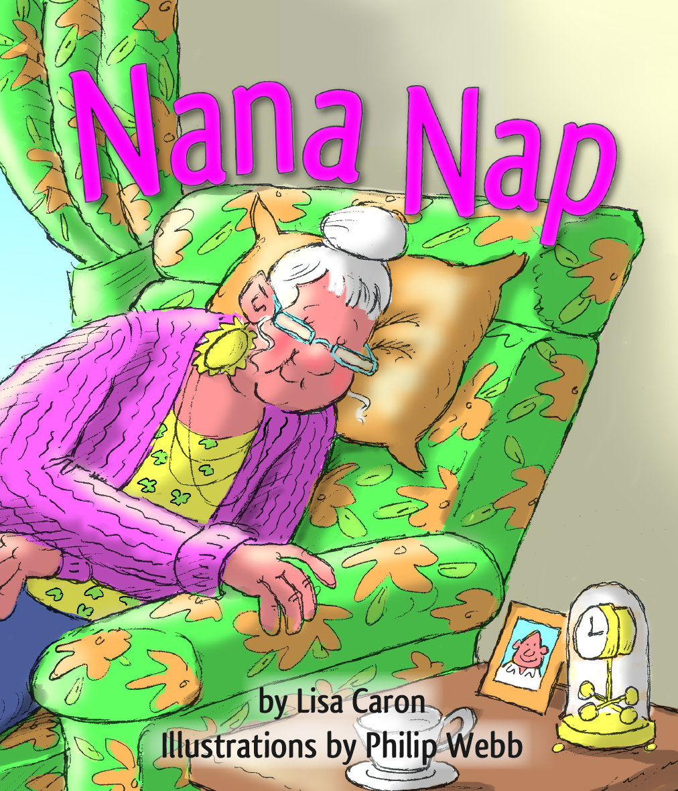
CLOZE ACTIVITY

Name: ____________________________________________
Date: _______________________________
Nana Nap

When Nana was tired she decided to have a nap. What kept her awake? Did she have a nap?

Nana looked out the window at her garden.
“I should weed my garden,” she said, and she yawned.
Nana looked at her car.
“I should clean my car,” she said,
and she yawned again.

Nana looked at her chair.
“I should weed my garden,
and I should clean my car.
But I am so tired I will
have a nap first.”

Nana sat down on her chair.
She stretched out her legs.
She smiled and closed her eyes.

Tikatika, tikatika
went the jackhammer
on the neighbour’s path.
Nana sighed and rolled onto her side.

Brananana, Brananana
went the lawnmower next door.
Nana groaned and rolled onto her other side.

Woof, Woof,
Woof! Woof!
went the neighbour’s dog.
Nana moaned and put
her hands over her ears.

Rizzzzzzzzz,
Rizzzzzzz
went Grandad’s drill
right outside the window.

“I cannot sleep with
all that noise!”
Nana told Grandad.

“I’m sorry, I can’t hear you,”
said Grandad.

“That is better,” said Nana ...

. . . and she was soon fast asleep.

