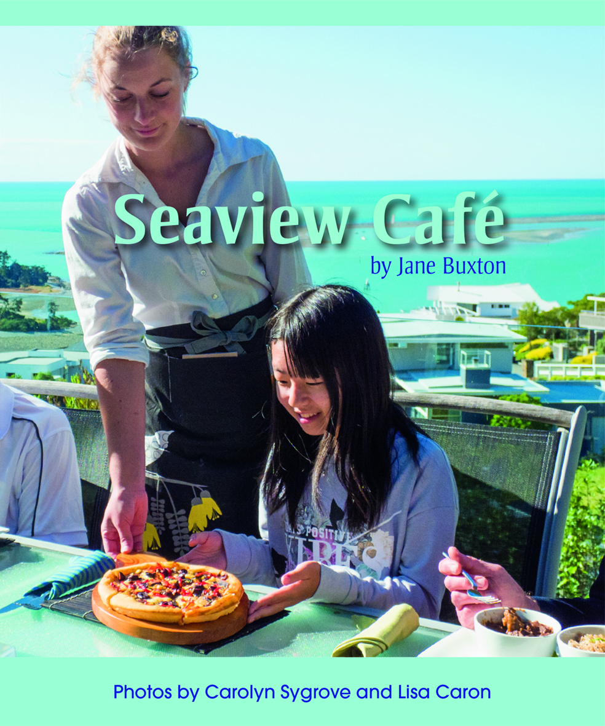
CLOZE ACTIVITY

Name: ____________________________________________
Date: _______________________________
Seaview Café

My family and friends are having lunch at a café. The waiter brings our food. The noodle salad is for me, but who ordered the fish?

My family and friends are having lunch at Seaview Café.
We read the menu. The waiter takes our orders.
The chefs cook our meals.
The waiter brings our food.
“Who is having beef curry?”
“I’m having beef curry. Thank you.”
“Who ordered spaghetti bolognese?”
“I ordered spaghetti bolognese. Thank you.”
“Who is the noodle salad for?”
“The noodle salad is for me, please.”
“Who ordered falafel?”
“I did. I ordered falafel. Thank you.”
“Nachos. Who is having nachos?”
“I am. The nachos are for me. Thank you.”
“Is the sushi for you?”
“Yes, it is for me. Thank you.”
“Is the vegetarian pizza for you?”
“Yes it is, thank you. That looks delicious.”
“And fish. Two pieces of fish?
Who ordered just fish?”
“Purr ... purr.”

