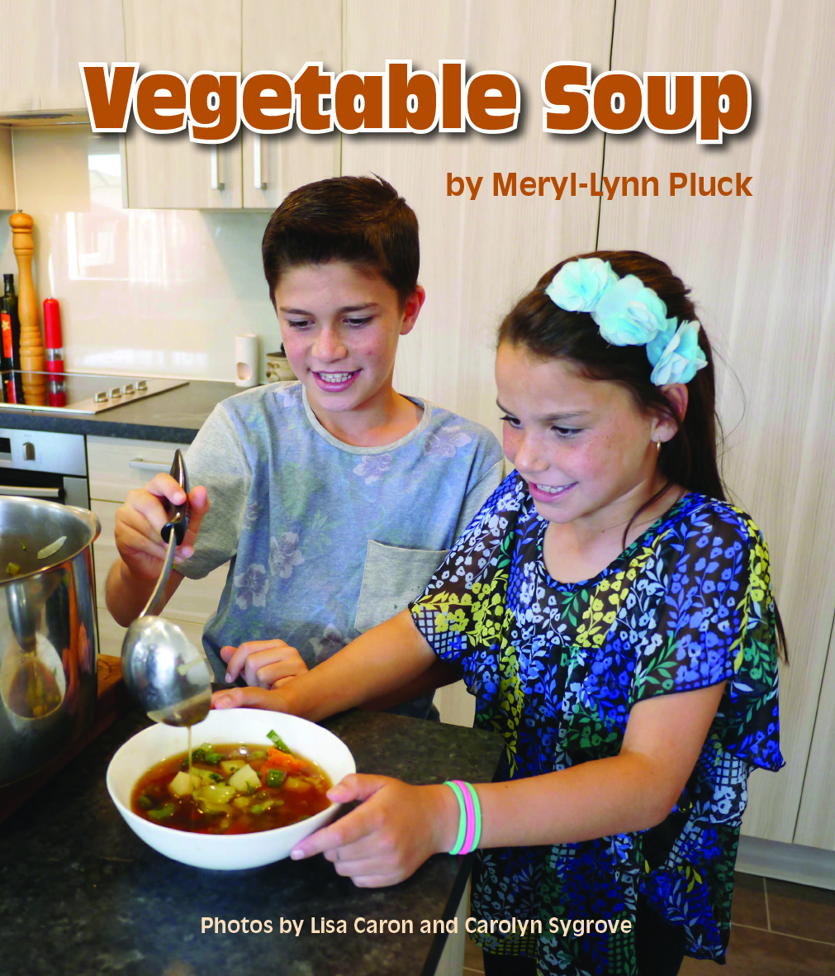
CLOZE ACTIVITY
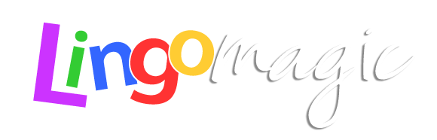

Name: ____________________________________________
Date: _______________________________
Vegetable Soup

The family in this book is making vegetable soup. What type of soup do you like? What is it called and what do you put in it?

My family is making soup for lunch.
My little brother is peeling two carrots. My big brother is cutting the carrots.
I’m putting the carrots in the pot.
Grandpa has three leeks from his garden.
Grandma is washing the leeks. Grandpa is cutting the leeks.
I’m putting the leeks in the pot.
My mother is peeling four onions. My father is cutting the onions.
I’m putting the onions in the pot.
My cousin has some celery. He is washing the celery.
My sister is cutting the celery.
I’m putting the celery in the pot.
Aunty Sallie has five potatoes. She is peeling the potatoes.
Uncle Joe is cutting the potatoes.
I’m putting the potatoes in the pot.

Aunty Lisa is washing broccoli for the soup.
Aunty Maria is cutting the broccoli. I’m putting
the broccoli in the pot.
My sister is putting water and salt and pepper
in the pot.
I’m stirring the soup.
We all like vegetable soup.

