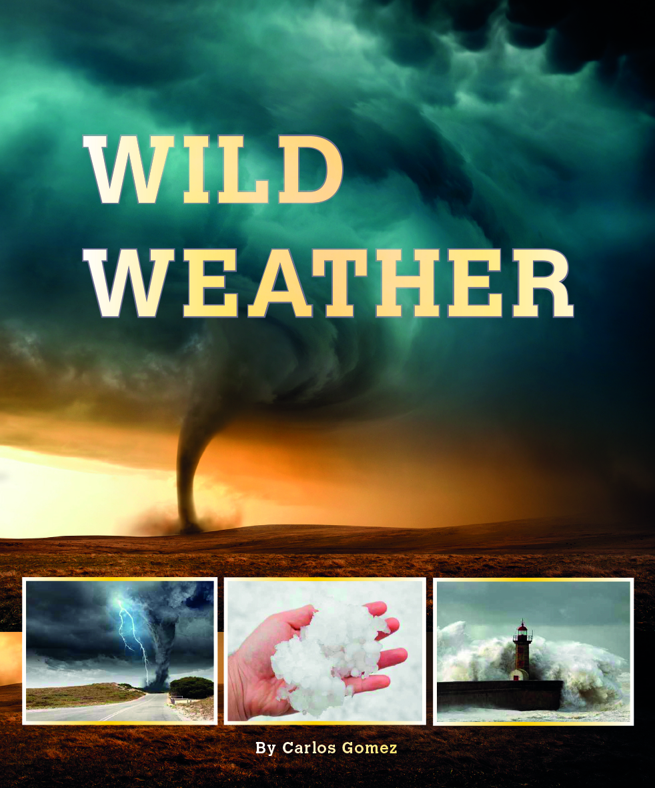
CLOZE ACTIVITY

Name: ____________________________________________
Date: _______________________________
Wild Weather

Some places on Earth have wild weather. Where on Earth does it get very hot?
Where is the coldest place on earth?
Where is the wettest place?

Some places on Earth have wild weather.

Hot Places
Some places in Australia get very hot.
The temperature there can reach 50 degrees Celsius*.
*50 degrees Celsius is about 122 degrees Fahrenheit.

It is so hot that you can cook an egg
on the ground there!

Cold Places
Antarctica is the coldest place on Earth.
The temperature there can drop
to minus 48 degrees Celsius*!
*Minus 48 degrees Celsius is about minus 54 degrees Fahrenheit.

This is colder than the inside of a freezer!

Wet Places
A mountain in Hawaii
gets the most rain on Earth.
It rains about 350 days a year there.
It is so wet that there are
only fifteen days a year
without rain!

Snowflakes
How big can snowflakes get?
One of the largest snowflakes ever seen
fell in Montana, USA.
One snowflake was 38 centimetres* wide,
which is bigger than a dinner plate!
*38 centimetres is about 15 inches.

Hailstones
How big can hailstones get?
Some hailstones are as big as tennis balls.
One of the biggest hailstones ever found
fell in Bangladesh.
It weighed more than a kilogram*!
*A kilogram is about 2 pounds.

Tornadoes
The United States gets more tornadoes than any
other country – usually around a thousand a year.
In spring, there can be up to five
tornadoes in a day!
Most tornadoes last for only
a few minutes, but the biggest
ones can blow for hours.

Some tornadoes travel across several states
through an area known as ‘Tornado Alley’.

That is wild weather!

