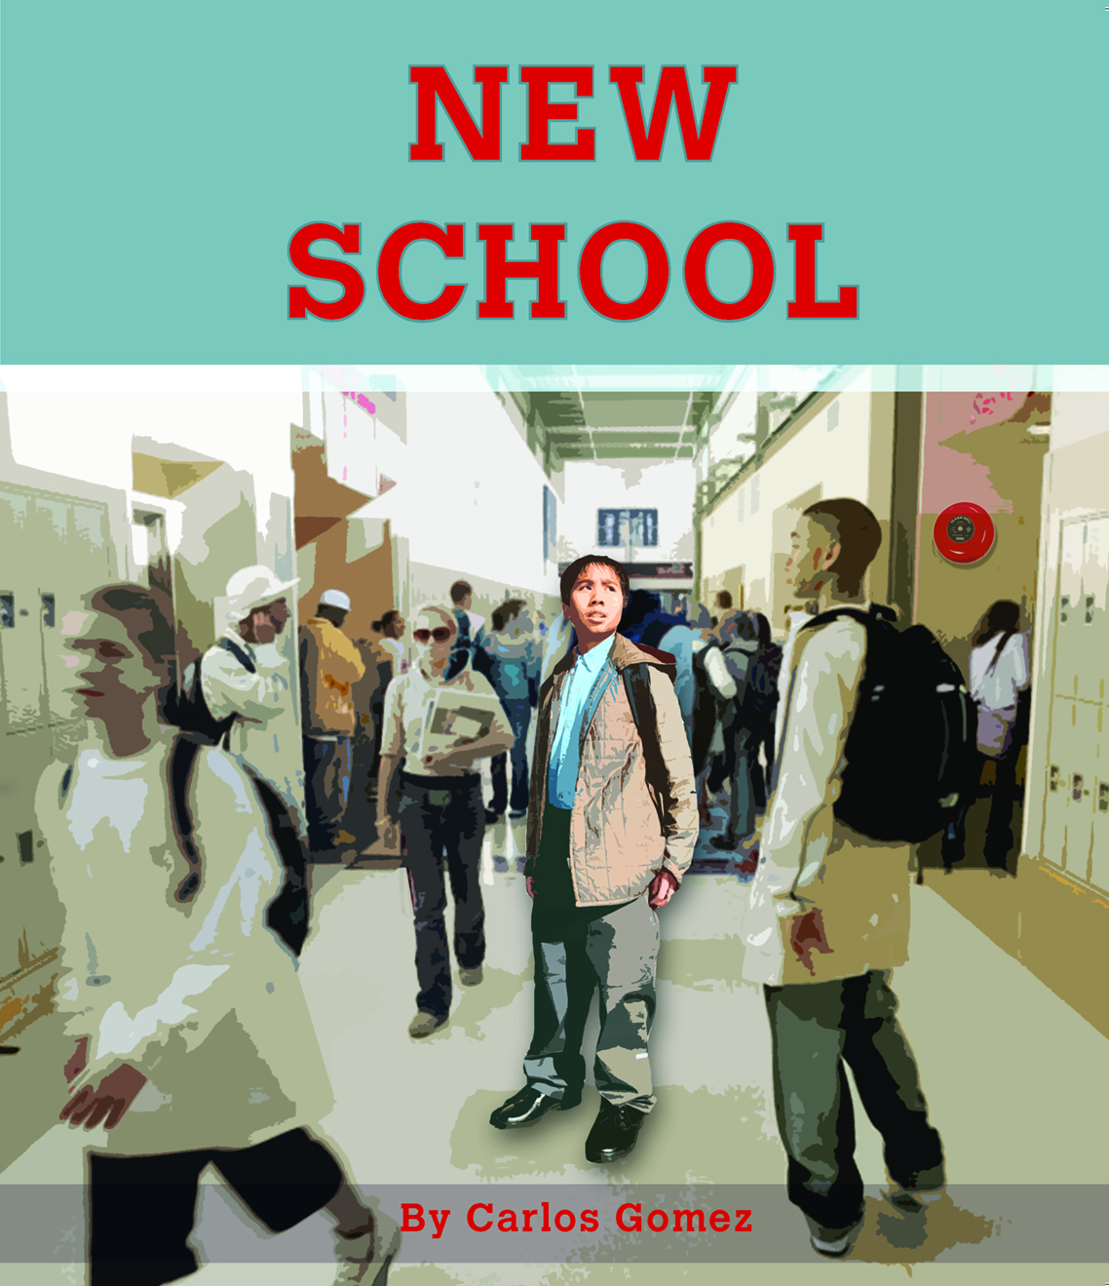
CLOZE ACTIVITY
Name: ____________________________________________
Date: _______________________________
New School

It is Kwan’s first day at a new school. How will he fit in on his first day at school?
How will he know what to do?

It was Kwan’s first day at a new school.
The school principal took him to his new classroom.
She said, “This is Kwan. He is new to our school.”
“Welcome to Room 7, Kwan,” said the teacher.

Kwan heard voices behind him.
“Hello Kwan. I’m Mandy.”
“My name is Rebecca.”
“I’m Nicki.”
“Come and meet Tom,” said the teacher.

“Tom, this is Kwan. Kwan, this is Tom,”
said the teacher.
“Hello, Kwan. Sit at this desk, by me.
Can you speak English?” said Tom.
Kwan sat down by Tom.
“I am learning to speak English,” said Kwan.

Tom smiled.
Kwan smiled too.
“I will help you find your way around,” said Tom.
“Thank you,” said Kwan.

At lunchtime, Kwan ate his lunch.
Tom played basketball with his friends.
“Pass me the ball,” cried David.
“Take a shot,” yelled Mandy.
“My ball!” called Pita.

“Come and play with us, Kwan,” Tom called.
Kwan did not know what they were saying.
He did not know how to play basketball.

Kwan went to get a drink of water.
He heard a bell ring.
People ran past him.
He looked all around.
“Where is Tom?
Where is my classroom?” he whispered.

Kwan walked into a classroom,
but it was not his classroom.
He saw a teacher, but it was not his teacher.
“Can I help you?” asked the teacher.
“I am looking for Room 7,” said Kwan.

The teacher looked at a timetable
on his desk.
“Room 7 is at the jumping pit,”
he said.
“Thank you. I can see them now,”
said Kwan and he smiled.

Kwan walked over to the jumping pit.
“Kwan,” called Pita.
“Come over here,” said David.
“Can you do a long jump?” asked Rebecca.
Kwan smiled and said,
“Yes, I can do a long jump. Watch me.”

“Wow,” said Rebecca.
“That’s amazing,” said Pita.
“You can jump a long way,” said David.
“That is a very long jump,” said Nicki.
“Welcome to the school athletic team!” said Tom.
“Thank you,” said Kwan, and he smiled again.

